Name – Katariya Bhautik

Assignment 2025

Module 1 – Overview of IT Industry

1. Write a simple "Hello World" program in two different programming languages of your choice. Compare the structure and syntax.

ANSWER –

C Languages

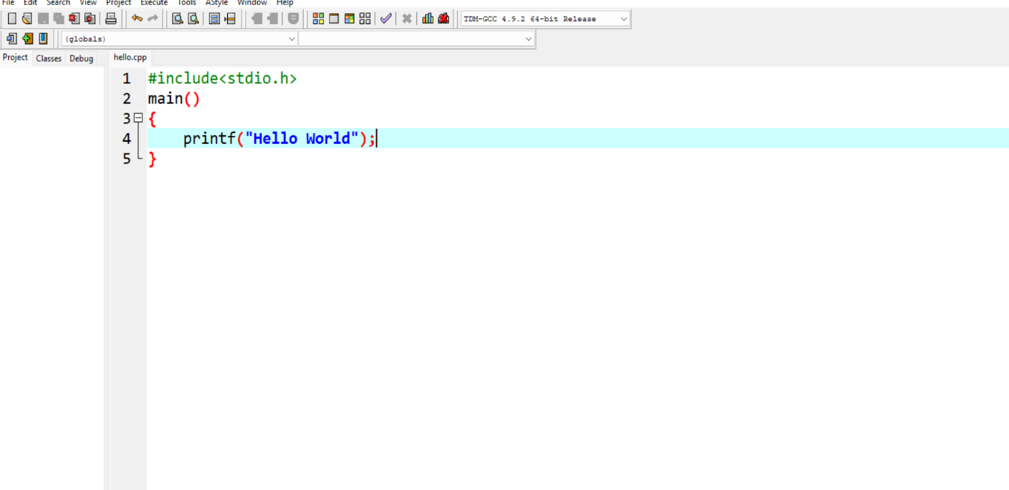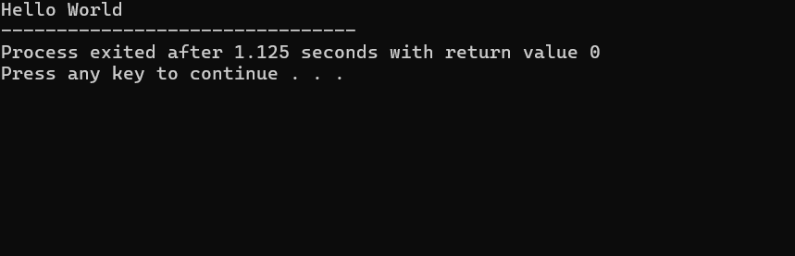

Program structure

C

1. **#include <stdio.h>**

It includes the Standard Input Output library needed to use the printf function.

1. **main()**

This is the main function where execution of the program begins.

1. **Printf()**

printf is a standard C function for output.

Each statement with a semicolon ;

**Syntax.**

**FEATURE C**

Hello world printf(“hello world”);

Variables data type must be declared :

Int.

**Types of Programming Languages**

**2.What are the main differences between high-level and low-level programming languages?**

**languages:**

| **Feature** | **High-Level Language** | **Low-Level Language** |
| --- | --- | --- |
|  |  |  |
| **Abstraction** | **Highabstraction from hardware; closer to human language.** | **Low abstraction; closely tied to machine hardware.** |
| **Syntax** | **Easier to read and write; uses English-like commands.** | **Harder to read; uses mnemonics (assembly) or binary/hex (machine code).** |
| **Portability** | **Highly portable across different hardware platforms.** | **Platform-dependent; works only on specific hardware.** |
| **Execution** | **Needs a compiler or interpreter to convert code to machine language.** | **Can be executed directly by the CPU (machine code) or with minimal translation (assembly).** |
| **Examples** | **Python, Java, C++, JavaScript** | **Assembly, Machine Code** |
| **Speed** | **Generally slower due to abstraction and translation.** | **Faster execution; optimized for hardware.** |
| **Ease of Development** | **Easier, less error-prone; suitable for complex programs.** | **Harder, more prone to errors; used for system-level programming.** |

|  |  |  |
| --- | --- | --- |
| **Memory Management** | **Mostly automatic (garbage collection, etc.)** | **Manual; programmer must manage memory directly.** |

**World Wide Web & How Internet Works:**

**3.Research and create a diagram of how data is transmitted from a client to a server over the internet.**

ANSWER..

**Steps of Data Transmission**

1. Application Layer (Client Request)

• The user performs an action such as typing a URL in a browser.

• The application (for example, Chrome) generates a request using HTTP or HTTPS.

1. **Transport Layer (TCP/UDP**)

• The request is divided into smaller segments.

• TCP ensures reliable delivery by using handshakes, sequencing, and retransmission if necessary.

• UDP is faster but less reliable, commonly used in streaming and gaming.

1. **Network Layer (IP)**

• Each segment is placed inside an IP packet with the source and destination IP addresses.3

• The IP address tells the packet where to go, but not the exact path.

1. **Data Link Layer (Ethernet / Wi-Fi)**

• Packets are converted into frames suitable for the local network.

• MAC addresses are used to deliver data within the LAN or Wi-Fi connection.

1. **Physical Layer (Wires / Fiber / Wireless Signals)**

• Frames are converted into electrical signals, light pulses, or radio waves depending on the medium.

1. **Internet Infrastructure (Routers and ISPs)**

• Routers examine the destination IP address and forward packets along the best path.

1. **Server Receives Data**

• The server receives the packets.

• The transport layer reassembles them into the original request.

• The application layer (such as a web server) processes the request.

Types of Internet Connections

**4**.**Research different types of internet connections (e.g., broadband, fiber, satellite) and list their pros and cons**

ANSWER –

Types of Internet Connections

1. **Broadband (DSL/Cable)**

• Pros:

o Widely available in urban and semi-urban areas. o Provides relatively fast and stable internet compared to dial-up. o Can support multiple devices simultaneously.

• Cons:

o Speed may decrease during peak usage hours. o Requires wired infrastructure. o Upload speeds are usually lower than download speeds.

1. **Fiber-Optic Internet**

• Pros:

o Extremely high speed (up to 1 Gbps or more). o Very reliable with minimal interruptions. o Equal upload and download speeds (symmetric).

• Cons:

o Limited availability, mostly in cities. o Installation cost is higher compared to DSL/cable.

1. **Satellite Internet**

• Pros:

o Can be accessed in remote and rural areas where other connections are not available. o Easy installation without complex wiring.

• Cons:

o High latency (delay) makes it less suitable for gaming or video calls. o Weather conditions (rain, storms) can disrupt the connection. o Data caps are often imposed by providers.

1. **Mobile Data (3G/4G/5G)**

• Pros:

o Portable and can be used anywhere with cellular coverage. o Easy to set up with smartphones or portable hotspots. o 5G provides very high speed and low latency.

• Cons:

o Dependent on network coverage quality. o Data plans can be expensive.

1. **Dial-up Internet (Older Technology)**

• Pros:

o Very low cost. o Can work in areas with just a telephone line.

• Cons:

o Very slow (maximum ~56 kbps).